
ESOL
(English for Speakers of Other Languages)

Cardiff & Vale College

Welcome 2024-2025
1 Canal Parade




Course code:
Course description:
Teachers’ names:
Teachers’ email:

The ESOL leadership team:

Vice Principal | Yusuf Ibrahim
Head of ESOL | Judith Scanlon
Deputy Heads of ESOL | Cathy Tong  Sophie Curien
Departmental Administrators | Carol Stewart  Laura Evans

www.cavc.ac.uk
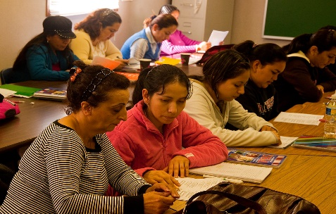
This Photo by Unknown Author is licensed under CC BY-ND

Welcome!
We are happy to see you at Cardiff & Vale College, and hope you have an excellent time learning English with us this year.

Here is some information about the college, and what is expected from both students and teachers.

Cardiff & Vale College (CAVC)
CAVC is a very big college in Wales. There are over 30,000 students. There are over 1500 learners studying ESOL.
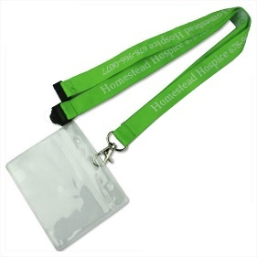
1 Canal Parade
You must wear your student ID card and lanyard at all times.

Toilets

There are toilets on every floor.
Don’t forget to wash your hands every time you use the toilets.

Lifts & Stairs
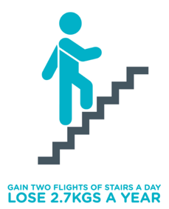
There are lifts and stairs.
We share the lifts and stairs with all the people in the building.


Success Centre

The Success Centre is in the main City Centre Campus.
It is a library with books and computers on the 2nd floor.
You can visit the Success Centre any time.
It is open from Monday to Friday from 8:30 am – 4pm.
If you want to book a computer or study area you need to email the staff at successcentre@cavc.ac.uk


Skills Centre
In the success centre, you also can get extra help with English, Maths and Computers.
The Success Centre can help ESOL students with:

- Borrowing books
- Reading practice
- Going online
- Printing and photocopying
- Opening your student email
- Checking your attendance
- Extra speaking practice

If you would like some help or support you need to ask your teacher to make an appointment. They will contact the staff at: learningcoach@cavc.ac.uk

Student Services

Student Services are in an office near reception in the City Centre campus.
Ask at reception and they can help you to find it.
Student Services can help you with general course or college information.
Student Services have some forms for student finance.
Please ask your teacher for any letters you may need, before going to Student Services.

Health & Safety

Be safe in the college.
Always follow the rules in the college.
If you have any medical problems, allergies or conditions, you must tell your teachers.
If you see anything unsafe, please tell the staff immediately.

Fire Procedures
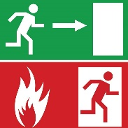
Classrooms have a sign saying what to do if there is a fire.
Please read the sign carefully and speak to your teacher if you need more help.
Sometimes there is a Fire Drill. This is to practise leaving the building in a safe way if there is ever an emergency.

DO NOT use the lift if you can hear a fire alarm.
If you have difficulty going up or down stairs, please talk to your teacher to help plan what to do in case of a fire.

Eating & Drinking


In the classroom – water is okay.
In the classroom – food and hot drinks are NOT ALLOWED.

Be careful with water in classrooms when you are using a computer.

The college has got a café and a shop.
Food and drinks are available at the café and shop in the main building.
Please let your teacher know if you have any food allergies.


Keep It Tidy

Please put your rubbish in the bin.
Use the bins in the Ground floor foyer.
Classrooms bins are for recycling only (paper, plastic bottles).
Chewing gum is NOT ALLOWED in the classrooms.

Bicycles and scooters

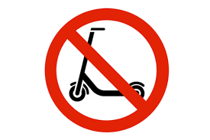
E-scooters are NOT ALLOWED in the college buildings.

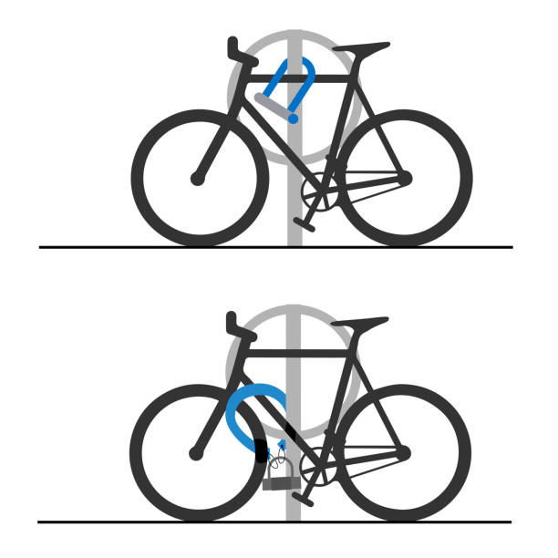
If you come to college by bicycle or e-scooter, please use a good quality lock. There are a few different places you can lock your bicycle: 1) Near reception at 1 Canal Parade. 2) In front of City Centre reception. 3) Behind City Centre campus (go through the car park at the back). The safest place to lock your bicycle is number 3. If you are not sure, ask your teacher to show you.

What do these signs mean? You will see them in the college.
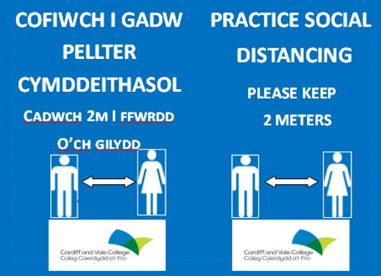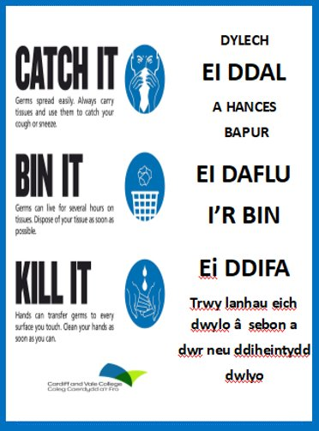



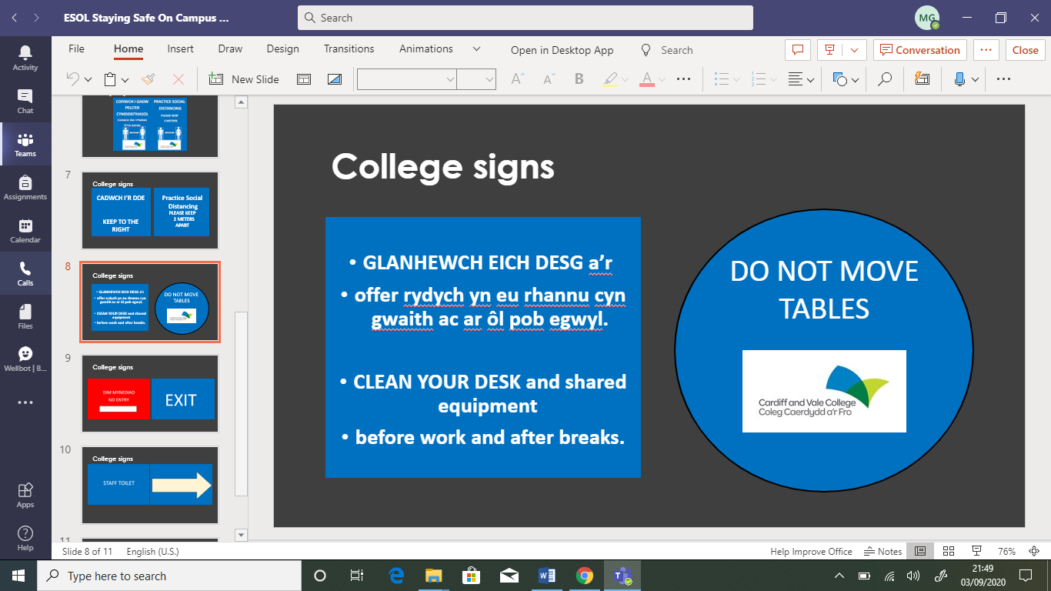


Student Absence

We keep a register for all your classes. We keep a register for your classes in college and online.
It is very important that you attend all your classes.
If you have a problem and you can’t come to class – please tell your teacher.
If you have a problem and you can’t study online – please tell your teacher.
Sometimes you will have an appointment outside the college. You need to ask for an appointment at a different time from your class, if possible.
If you can’t choose the time of your appointment, and you will miss your class – please tell your teacher.
If you have a letter for your appointment, you can show your teacher the letter.
If you have a text message with an appointment, you can show your teacher.

If you will miss your class, call the college and leave a message: 02920 250 263 or message your teacher on Teams

Hello, my name is ___________.
My student number is ___________.
My teacher’s name is___________.
I can’t come to class today because _________________________________.

CAVC Calendar
Term | Activity | Starts | Ends
Autumn 2024 | Induction week | 2nd September | 6th September
 | Autumn term | 2nd September | 20th December
 | Half-term | 28th October | 3rd November
 | Christmas break- college closed | 21st December | 5th January
Spring Term 2025 | Spring term | 6th January | 10th April
 | Half-term | 24th February | 28th February
 | Easter break | 14th April | 25th April
Summer Term 2025 | Summer term | 28th April | 20th June
 | Half-term | 26th May | 30th May

Timetable - Your teacher will give you your timetable

 | Start | Finish | Teacher
Monday
Tuesday
Wednesday
Thursday
Friday

